**SYNOPSIS ON**

**“Speech Recognition”**

ACKNOWLEDGEMENT

**Keep away from people who try to belittle your ambitions. Small people always do that, but the really great make you feel that you too, can become great.**

I take this opportunity to express my sincere thanks and deep gratitude to all those people who extended their wholehearted co-operation and have helped me in completing this project successfully.

First of all, I would like to thank **Mr. Subhdeeep Sir, Director, EME Technologies** for creating opportunities to undertake me in the esteemed organization.

Special thanks to **Mrs. Parul Maam** Project Manager for all the help and guidance extended to me by him in every stage during my training. His inspiring suggestions and timely guidance enabled me to perceive the various aspects of the project in a new light.

I also want to thank my teammates, friends and staff members of BTECH department that have shared their needs and experiences with me.

My report will remain incomplete if I do not make a mention about my parents who expended all moral and financial support to me. I would like to special thanks to my parents.

.

**Name- Ankit Kumar**

**B.TECH 5TH SEM**

# 

**INTRODUCTION**

**Speech Recognition**

Have you ever talked to your computer? (And no, yelling at it when your Internet connection goes down or making polite chit-chat with it as you wait for all 25MB of that very important file to download doesn't count). I mean, have you really, really talked to your computer? Where it actually recognized what you said and then did something as a result? If you have, then you've used a technology known as speech recognition.

Speech recognition allows you to provide input to a system with your voice. Just like clicking with your mouse, typing on your keyboard, or pressing a key on the phone keypad provides input to an application, speech recognition allows you to provide input by talking. In the desktop world, you need a microphone to be able to do this.

The suitable of computerization for an application may be determined as follows:

**Volume of storage and calculation:** Computerization is best suited to handle large volume of data. The sufficient, economic and reliable storage characteristic of computer media must be exploited properly.

**Quality of Output:** Quality of output in terms of accuracy, elegance of output, aesthetics in formality through use of word processing and powerful editing could justify use of a computer.

**Computerized solutions should be cost justifiable:** Money, time saving and efficiency justify the cost of preparing writing and executing a program, Now-computer devices such as calculator can perform money tasks more economically.

**PURPOSE: -**

Speech recognition is an alternative to traditional methods of interacting with a computer, such as textual input through a keyboard. An effective system can replace, or reduce the reliability on, standard keyboard and mouse input. This can especially assist the following:

* People who have little keyboard skills or experience, who are slow typists, or do not have the time or resources to develop keyboard skills.

**Objectives:-**

The main Objective of this project is to provide better opportunities for people of all age groups.

**Privacy:-**

Privacy can be kept by secure login using Gmail password.

**Practicality:-**

The system is stable and can be operated with average intelligence.

**Efficiency: -**

There should be balance amongst various factors like accuracy, comprehensiveness on one hand and response timeliness of the system on the other hand.

**Cost:-**

It is desirable to aim for the system with a minimum cost subject to the condition that it must satisfy the entire requirement.

**Flexibility:-**

The system should be modifiable depending on the changing needs of the user. Such modifications should entail extensive reconstructing. It should also be portable to different computer systems.

**Security:-**

This is very important aspect requiring rigorous designing of database including hardware reliability, fallback proedures and physical security of data.

**LANGUAGE USED:**

**Python:-**

The objective of this final project was to design and implement a complex digital system combining voice, video and user interfaces. The analysis presented in the previous sections shows a fully functional control units, video displays, user interfaces, and voice extraction system. In addition, it includes a fully functional voice modulation algorithm, and a partially functional voice modulation system. A comprehensive testing and debugging methodology was utilized, which validated the functionality of the different modules.

Overall this project could have been a great success. However, due to time constraints and the complexity of what the team wanted to do impeded the integration of all modules and the completion of our project.

**INTRODUCTION TO IDLE**

Term used to describe when something is operating, but is not being used. For example, when your computer is on, but you are not doing anything with it, it is **idle**. Today, when a computer or electronics device is idle for too long it may go into an [energy conserving mode](https://www.computerhope.com/jargon/e/energyst.htm) or standby to save power.

When referring to a [process](https://www.computerhope.com/jargon/p/process.htm) or [program](https://www.computerhope.com/jargon/p/program.htm), an **idle process** is any running process or program that is using computer resources but is not actively being.

When referring to chat, an idle user (**idlers**) refers to someone who is logged into the chat, but hasn't been actively chatting for several minutes. Often these are users who're away doing other things such as eating or sleeping, but want to remain on to view the conversations that happened while they were gone.

**ER Diagram:**

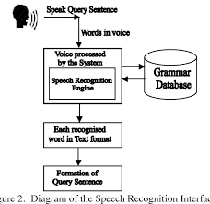

**DataFlowdiagram:**

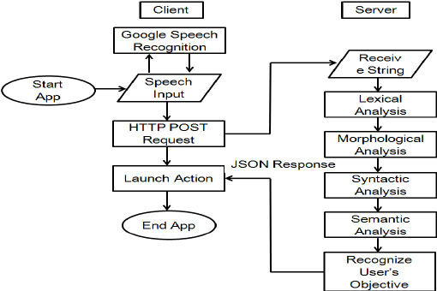

**BIBLIOGRAPHY:-**

1) [www.google.com](http://www.google.com)

2) [www.wikipedia.org](http://www.wikipedia.org)

3)[www.w3school.com/](http://www.w3school.com/)

4)[www.devguru.com/](http://www.devguru.com/)

5)[www.w3.org/](http://www.w3.org/)

6) www.tutorialspoint.com/python/